September 18, 2010, 4:00-8:00
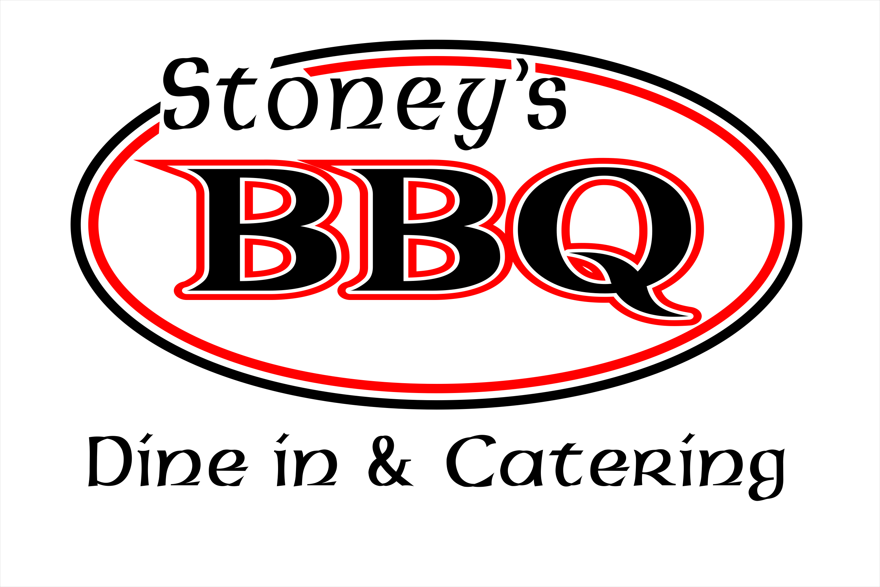

Bring your car, Bring your friends

Come enjoy great BBQ & music while
showing or viewing awesome cars



Part of the proceeds will support a local charity
The Rice Vinskus Scholarship

The Rice Vinskus Scholarship provides financial assistance to children of breast cancer parents, enabling them to pursue a higher
education and encouraging them to become caring, committed citizens willing to help make a difference by giving back to others. We currently support five local students. Please visit our website @ www.RVScholarship.org.

Directions: From Hwy 153 and 81, go 81 toward Anderson for about 4 miles - You will see the Stoney`s BBQ sign on Right on orr road. From 86 & 81 take 81 toward Powdersville. Appox. 1 mile on Left will be Orr Road. Turn there and BBQ will be on Right.

For more information, call (864) 220-6187

